Team Bustics  
- Gwiyoung Lee, Jinpyo Lee, Yeseul Hwang, Jiyoung Choi, Youngsung Kim, Jungeun Yun

Professor Jevin West

Data Science and Management

July 09th, 2015



Kim Youngsung Yeseul Hwang Jungeun Yun Gwiyoung Lee Jiyoung Choi

**Preliminary Analysis and Summary**

1. About Observations

The dataset we are going to analyze is ‘BMI rate and its correlation with gender and income level’ research conducted by National Health Insurance Corporation and National Statistical Office of Korea. In order to do our analysis we used datasets of year 2011, 2012, and 2013. Each year’s income level is divided into twenty levels. In total we utilized 60 observations.

First, we want to find out the correlation between BMI rate and ‘gender’. We live in a world that is image obsessed. Good appearance was important at all times. However, it is more important than ever these days. Good look is what makes us not only charming and attractive, but also helps getting a job in Korea. This is because a nice fit body gives a optimistic impression about that person to others. Therefore, it is so natural for both genders use their time and effort to take care of the way they look. These days, women prefer slim body than chubby body. Men prefer a firm, muscular body than a muscleless body. We analyzed our datasets according to gender and years 2011, 2012, and 2013 to find out how BMI rate changed in time and gender.

Second, we assume that BMI rate as a high correlation with income level. Several years ago, a Korean newspaper treated an article that related BMI rate and wealth. It said that ‘fat’ gives the image of poor, unhealthy, and lazy while ‘slim’ gives a pleasant image. In Korean there are many mediums that help one lose weight such as a health club, beauty salon treatment, and plastic surgery. Yet, all of these mediums require money. Also, cheap fast food is high in calories while expensive healthy food is rather expensive. It seems as if it is much easier for the wealth to lose weight than the poor. In order to study the correlation between BMI rate and income level, we divided income level in 20 and observed the change of BMI rate in year 2011, 2012 and 2013.

1. Descriptive Statistics and Plots

In the plot about our dataset, we can see that it has minus relationship. Income variable’s mean is 10.5, year1 variable’s mean is 0.4045, and year2 variable’s mean is 0.4435, year3 variable’s mean is 0.518. And is standard deviation is respectively 5.92

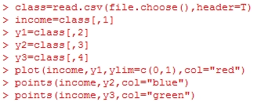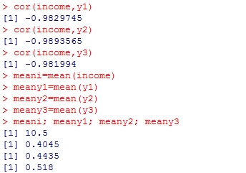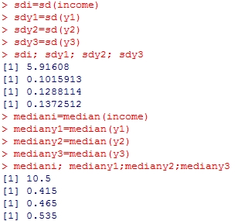

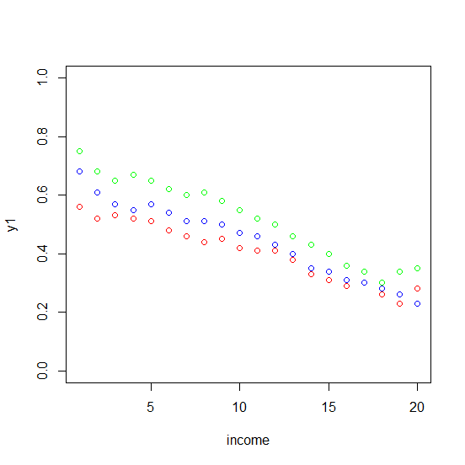

4. Plan of Analysis

To find out what we are looking for, we chose several statistical methods for the data. So far, we derived the mean, standard deviation, and median of our 60 observations. Also, we drew a scatter plot of BMI rate, x-axis as income, y-axis as BMI rate, and three colors representing the year 2011(red), 2012(blue), and 2013(green). From the scatter plot, we found out that BMI rate and income level shows a negative correlation. Also, the BMI rate of year 2013 is slightly higher than 2013, flowed by 2011. We would further focus on the two points that we derived from our scatter plot and verify these points.